**Aim:**

To write a program to analyze insertion and selection sort.

**Theory:**

**Insertion Sort** is a simple sorting algorithm that works by sorting an array one element at a time. It works by dividing the array into two parts: the sorted part and the unsorted part. The algorithm starts by assuming that the first element of the array is already sorted and then iterates through the remaining elements, inserting each element into its proper position in the sorted part of the array.

Insertion Sort has a time complexity of O(n^2), making it less efficient than other sorting algorithms such as Quick Sort or Merge Sort. However, it is often faster than these algorithms for small arrays or partially sorted arrays.

The algorithm is simple to understand and implement, making it a popular choice for simple sorting tasks. It is also an in-place sorting algorithm, meaning it does not require additional memory to sort the array, making it useful for situations where memory is limited.

Overall, Insertion Sort is a useful algorithm for sorting small or partially sorted arrays efficiently. Its simplicity and in-place nature make it a popular choice for simple sorting tasks.

**Selection Sort** is a simple sorting algorithm that works by repeatedly finding the minimum element from the unsorted part of an array and putting it at the beginning of the sorted part of the array. The algorithm works by dividing the array into two parts: the sorted part and the unsorted part. The sorted part is initially empty, while the unsorted part contains all the elements of the array.

Selection Sort has a time complexity of O(n^2), making it less efficient than other sorting algorithms such as Quick Sort or Merge Sort. However, it is useful for small arrays or partially sorted arrays.

The algorithm is simple to understand and implement, making it a popular choice for simple sorting tasks. It is also an in-place sorting algorithm, meaning it does not require additional memory to sort the array, making it useful for situations where memory is limited.

Overall, Selection Sort is a useful algorithm for sorting small or partially sorted arrays efficiently. Its simplicity and in-place nature make it a popular choice for simple sorting tasks.

**Algorithm:**

**Insertion Sort:**

InsertionSort(A)

for i = 1 to length(A) - 1

key = A[i]

j = i - 1

while j >= 0 and A[j] > key

A[j+1] = A[j]

j = j - 1

end while

A[j+1] = key

end for

end InsertionSort

**Selection Sort:**

SelectionSort(A)

for i = 0 to length(A) - 1

min_idx = i

for j = i + 1 to length(A) - 1

if A[j] < A[min_idx]

min_idx = j

end if

end for

temp = A[i]

A[i] = A[min_idx]

A[min_idx] = temp

end for

end SelectionSort

**Example:**

**Insertion Sort:**

Let the elements of array are –

Insertion Sort Algorithm

Initially, the first two elements are compared in insertion sort.

Insertion Sort Algorithm

Here, 31 is greater than 12. That means both elements are already in ascending order. So, for now, 12 is stored in a sorted sub-array.

Insertion Sort Algorithm

Now, move to the next two elements and compare them.

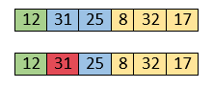

Here, 25 is smaller than 31. So, 31 is not at correct position. Now, swap 31 with 25. Along with swapping, insertion sort will also check it with all elements in the sorted array.

For now, the sorted array has only one element, i.e. 12. So, 25 is greater than 12. Hence, the sorted array remains sorted after swapping.

Insertion Sort Algorithm

Now, two elements in the sorted array are 12 and 25. Move forward to the next elements that are 31 and 8.

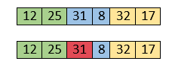

Both 31 and 8 are not sorted. So, swap them.

Insertion Sort Algorithm

After swapping, elements 25 and 8 are unsorted.

Insertion Sort Algorithm

So, swap them.

Insertion Sort Algorithm

Now, elements 12 and 8 are unsorted.

Insertion Sort Algorithm

So, swap them too.

Insertion Sort Algorithm

Now, the sorted array has three items that are 8, 12 and 25. Move to the next items that are 31 and 32.

Insertion Sort Algorithm

Hence, they are already sorted. Now, the sorted array includes 8, 12, 25 and 31.

Insertion Sort Algorithm

Move to the next elements that are 32 and 17.

Insertion Sort Algorithm

17 is smaller than 32. So, swap them.

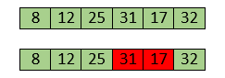

Swapping makes 31 and 17 unsorted. So, swap them too.

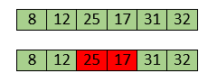

Now, swapping makes 25 and 17 unsorted. So, perform swapping again.

Insertion Sort Algorithm

Now, the array is completely sorted.

**Selection Sort:**

Let the elements of array are –

selection Sort Algorithm

Now, for the first position in the sorted array, the entire array is to be scanned sequentially.

At present, 12 is stored at the first position, after searching the entire array, it is found that 8 is the smallest value.

selection Sort Algorithm

So, swap 12 with 8. After the first iteration, 8 will appear at the first position in the sorted array.

selection Sort Algorithm

For the second position, where 29 is stored presently, we again sequentially scan the rest of the items of unsorted array. After scanning, we find that 12 is the second lowest element in the array that should be appeared at second position.

selection Sort Algorithm

Now, swap 29 with 12. After the second iteration, 12 will appear at the second position in the sorted array.

So, after two iterations, the two smallest values are placed at the beginning in a sorted way.

selection Sort Algorithm

The same process is applied to the rest of the array elements. Now, we are showing a pictorial representation of the entire sorting process.

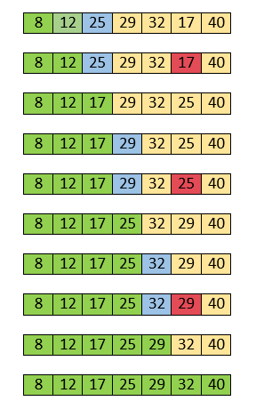

Now, the array is completely sorted.

**Algorithm:**

**Insertion_sort(A,n)**

For j = 2 to n

Key = A[j]

i = j-1

while(i>=1 && a[i]>key)

a[i+1] = A[i]

i—

A[i+1]=key

**Selection_sort(A,n)**

For i=1 to n-1

Imin = i

For j=i+1 to n

If(A[min]>A[j])

Imin=j

Temp = A[imin]

A[imin] = A[i]

A[i] = Temp

**Code:**

**Insertion Sort:**

#include<stdio.h>

#include<time.h>

//insertion sort

void main ()

{

int a[100000],i,j,temp,n;

clock_t start, end;

double cpu_time_used;

start = clock();

printf("Enter number of elements");

scanf("%d",&n);

for(i=0;i<n;i++)

{

a[i]=n-i; //worst case:- n-1,best case:- i, average case :- rand()

}

for(i=0;i<n;i++)

{

temp=a[i];

j=i-1;

while(j>=0 && a[j]>=temp)

{

a[j+1]=a[j];

j--;

}

a[j+1]=temp;

}

// for(i=0;i<n;i++)

// {

// printf("%d\t",a[i]);

// }

end = clock();

cpu_time_used = ((double) (end - start));

printf("time taken is %f",cpu_time_used);

}

**Selection Sort:**

//selection sort

#include<stdio.h>

#include<time.h>

void main ()

{

int a[50000],i,j,imin,temp,n;

clock_t start, end;

double cpu_time_used;

start = clock();

printf("Enter number of elements");

scanf("%d",&n);

for(i=0;i<n;i++)

{

a[i]=rand(); //worst case:- n-1,best case:- i, average case :- rand()

}

for(i=0;i<n;i++)

{

imin=i;

for(j=i+1;j<n;j++)

{

if(a[j]<a[imin])

{

a[imin]=a[j];

}

}

temp=a[i];

a[i]=a[imin];

a[imin]=temp;

}

// for(i=0;i<n;i++)

// {

// printf("%d\t",a[i]);

// }

end = clock();

cpu_time_used = ((double) (end - start));

printf("time taken is %f",cpu_time_used);

}

**Output:**

**Insertion Sort:**

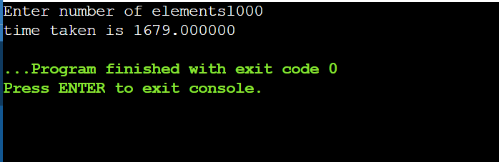

**Selection Sort:**

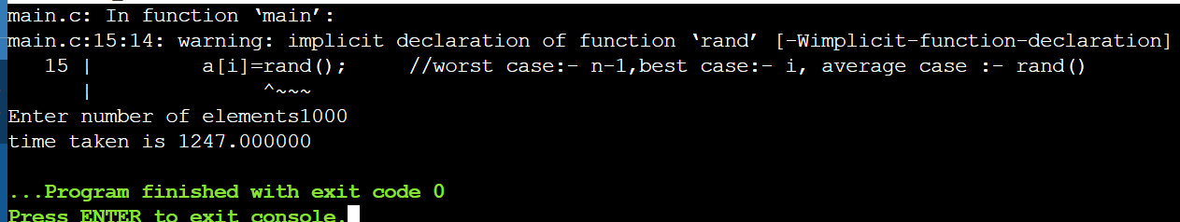

**Conclusion:**

Insertion Sort is a simple and efficient sorting algorithm that iterates over an array and places each element in its correct position in the sorted part of the array. It has a time complexity of O(n^2), making it suitable for small or partially sorted arrays.

Selection Sort is a simple and easy-to-implement sorting algorithm that iterates over an array, finds the smallest element in the unsorted part of the array, and places it at the beginning of the sorted part. It has a time complexity of O(n^2), making it suitable for small or partially sorted arrays.